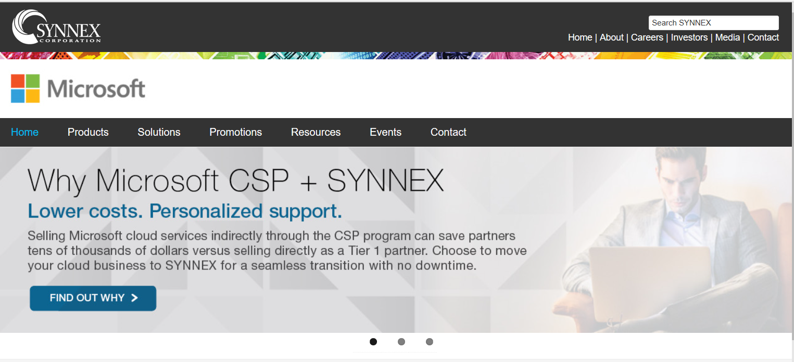

Link to Distribution Partner _ Microsite <https://www.synnexcorp.com/microsoft/>

Creative work example of banner ads & website branding, design, and content management.